Andree Salvo
Southern New Hampshire University
3-3 Project One Stepping Stone: Network Troubleshooting Practice
CYB 310
Instructor: Rachid Muller

Network Deficiencies
- Issue One
- Identify the Configuration Error
Validating that the Customer Data is in the file explorer
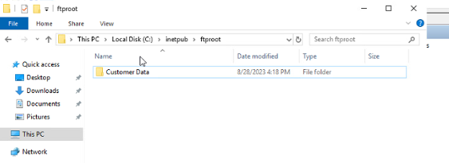
From the Customer Security Data Tab, we see that Sales and Customer Service have the right permissions. While HR is misconfigured.
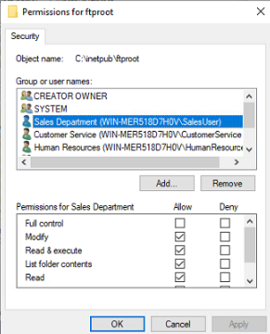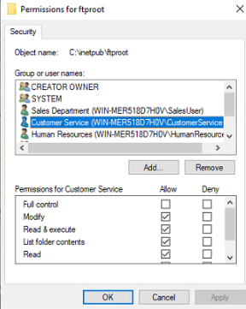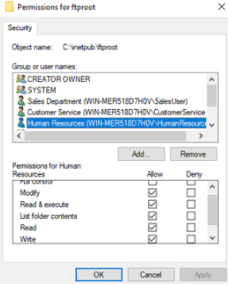

- Troubleshoot the issue & provide screenshots of the resolution
When troubleshooting, I went ahead and removed HR so that only the SalesUser and CustomerService have the correct permissions.
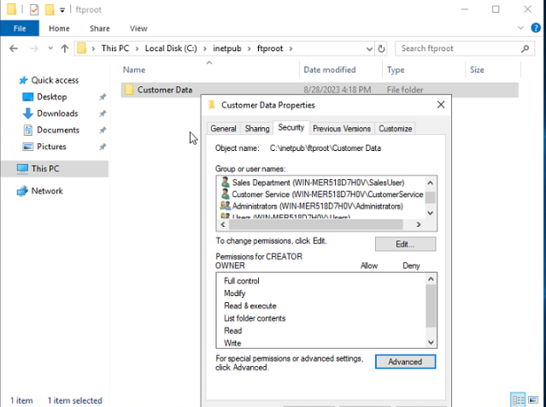
I went to the Internet Information Services Manager, went ahead to the FTP Authorization Rules, and granted SalesUser and CustomerServiceUser read and Write access.
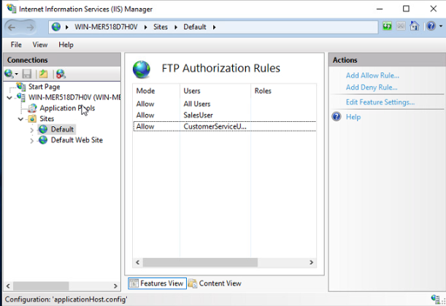

Proven fix on the client’s PCs (FileZilla)
HR got denied
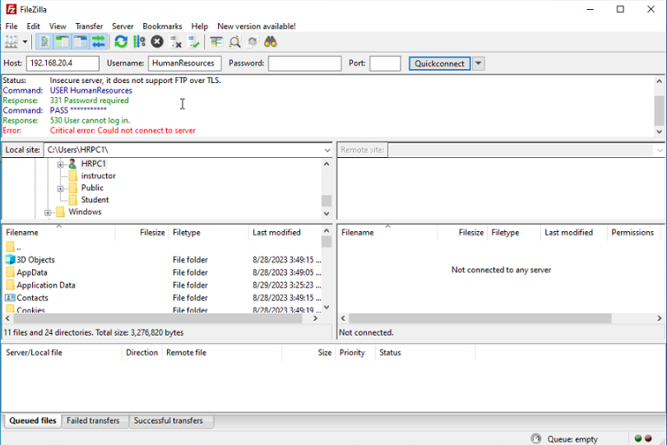
Sales was a successful login
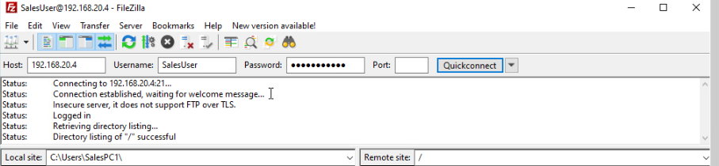
Customer Service was a successful login
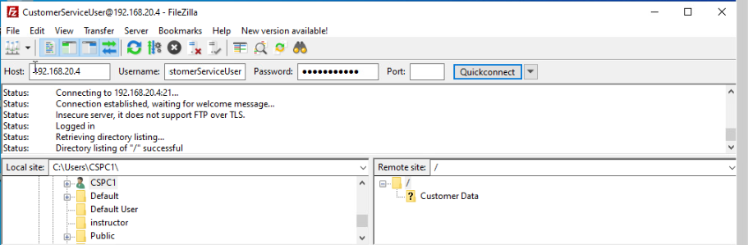

- Approach & justify your resolution
I checked the folder’s NTFS permissions on C:\inetpub\ftproot\Customer Data, disabled the inheritance, removed HR completely and kept Sales/CustomerService with the right access, and matched IIS FTP Authorization to allow only those users. Verified via FileZilla: HR denied (530), Sales/CustomerService allowed.
Justification: This enforces the least privilege and confidentiality (CIA triad) with defense-in-depth at NTFS and IIS, while maintaining access for Sales and Customer Service.

- Issue Two
- Configuration error
HR_PC1 is the only system capable of connecting to the internet, as evidenced by its successful ping to 8.8.8.8. PCs 2 and 3 are misconfigured with the wrong default gateway, while PCs 2 and 4 are also misconfigured at the switch level, as they are not on the same LAN 30 as PCs 1 and 3.
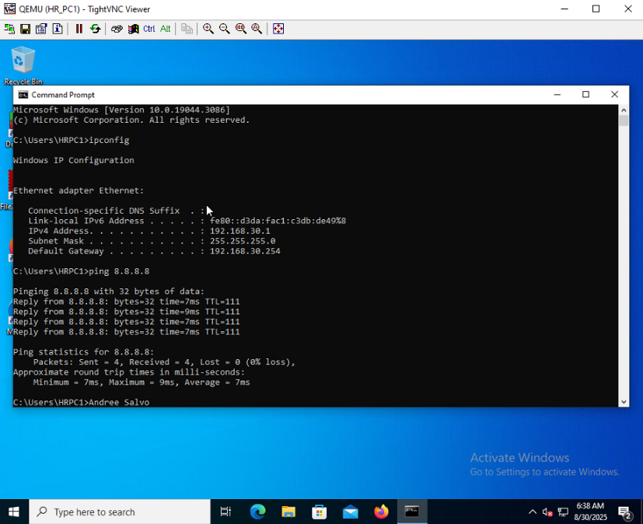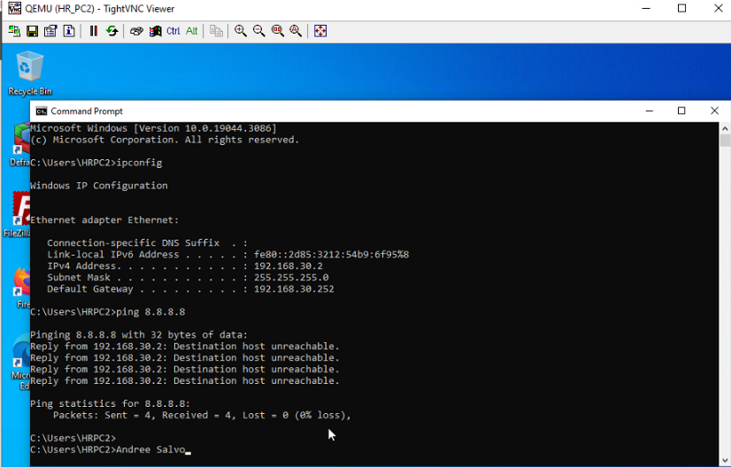
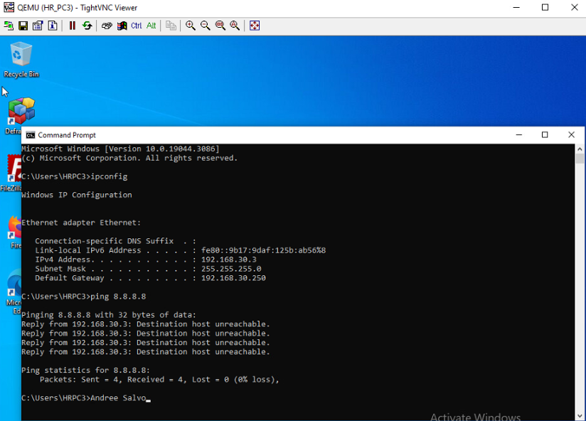
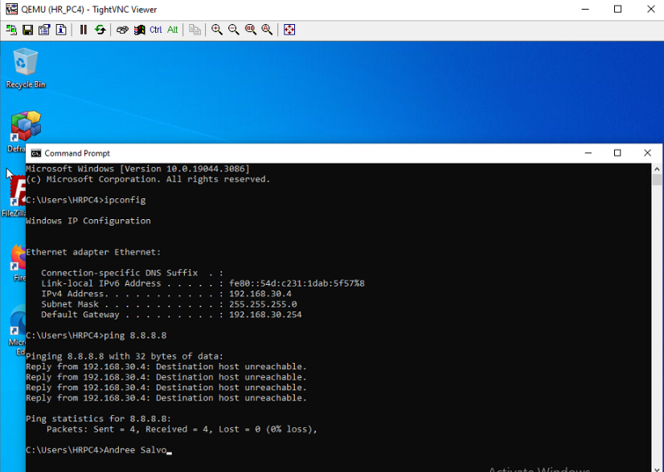
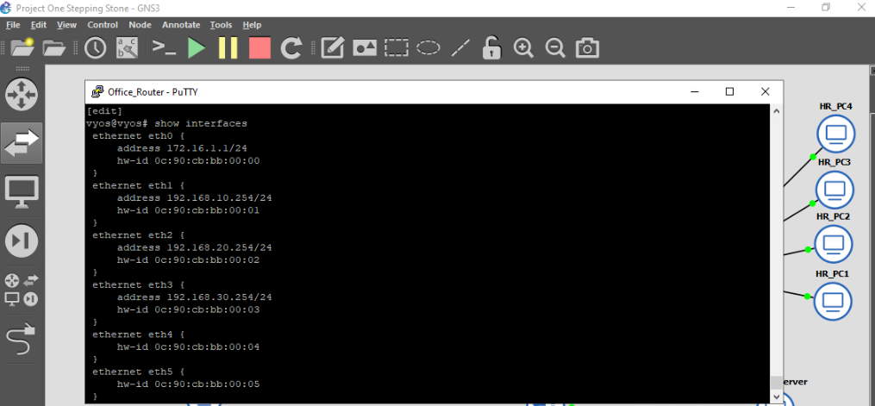
The Sales, Customer Service, and HR departments are connected through Ethernet1, Ethernet2, and Ethernet3.
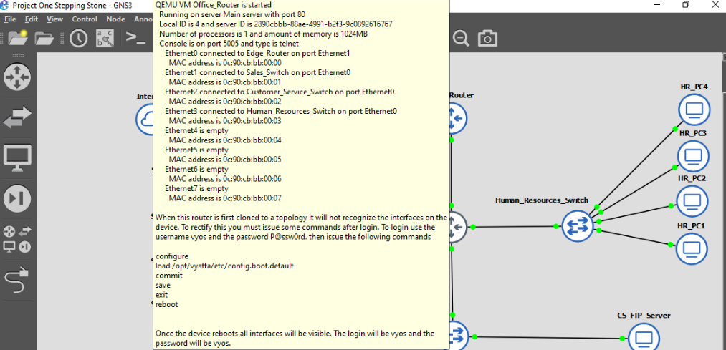

- Troubleshoot the issue and provide screenshots of a resolution
I fixed the switch to ensure all PCs are on the same LAN, specifically VLAN 30. The other two VLANs, 10 and 20, caused the issue because they couldn’t connect to the internet.
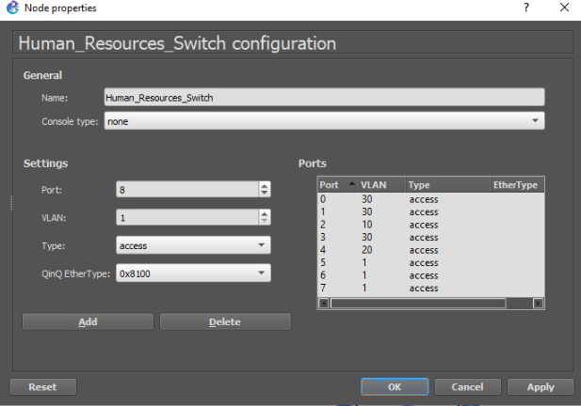
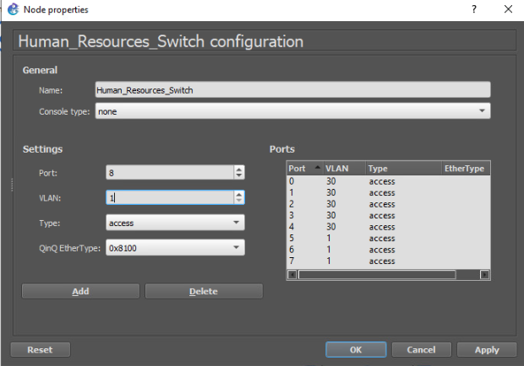

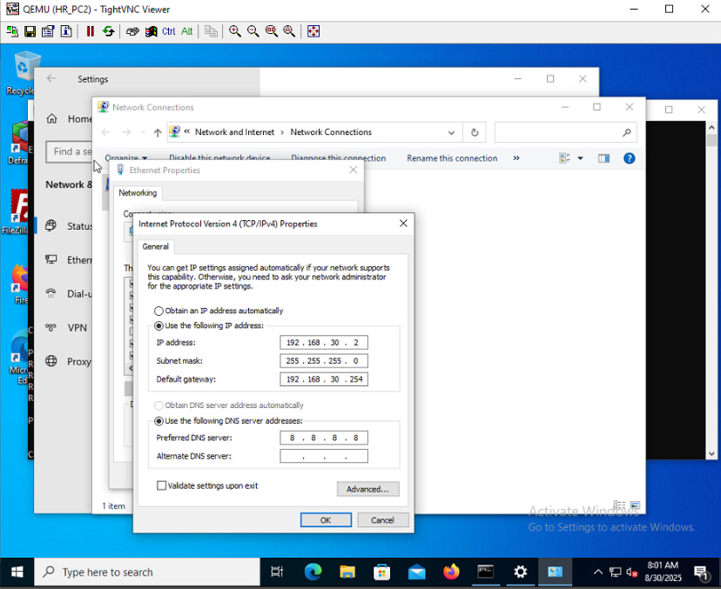
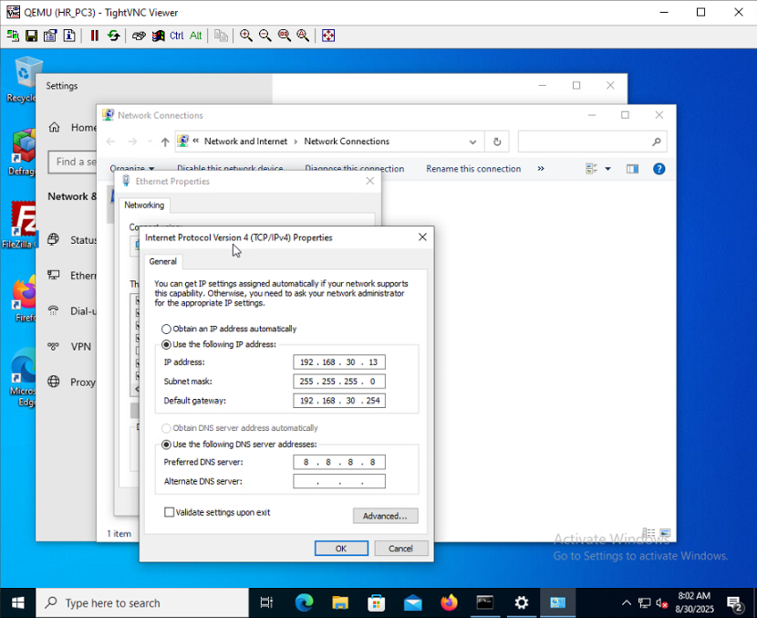
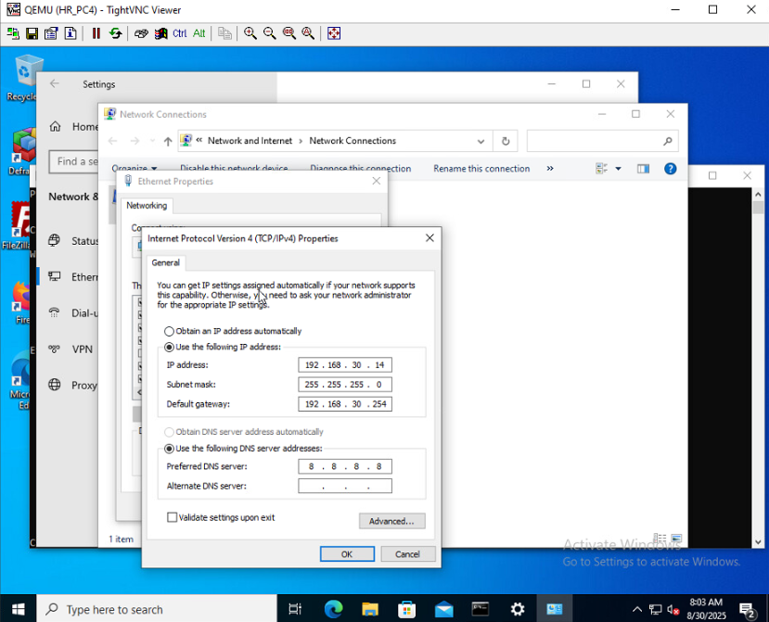
Each of the PCs should be directed to the default gateway of 192.168.30.254. And pinging it to the 8.8.8.8 DNS server should yield a successful result.
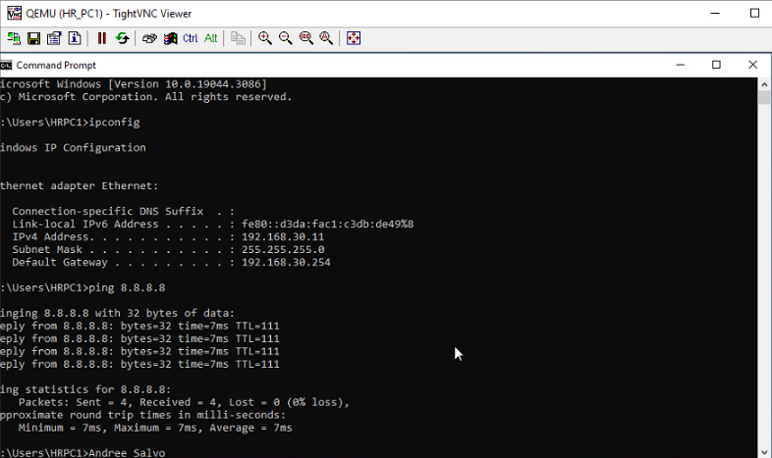
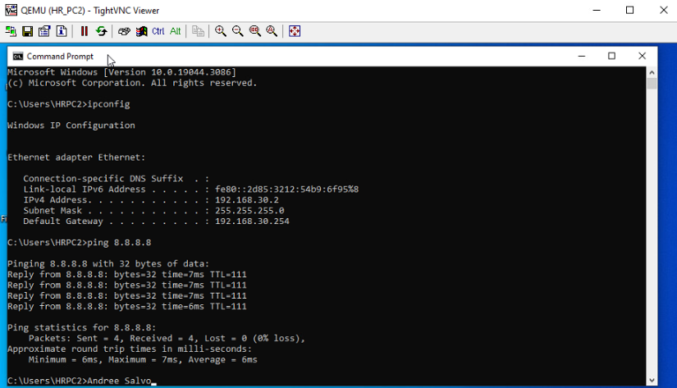
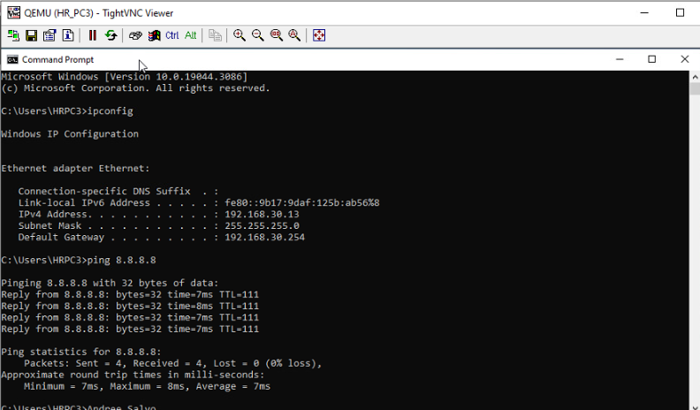
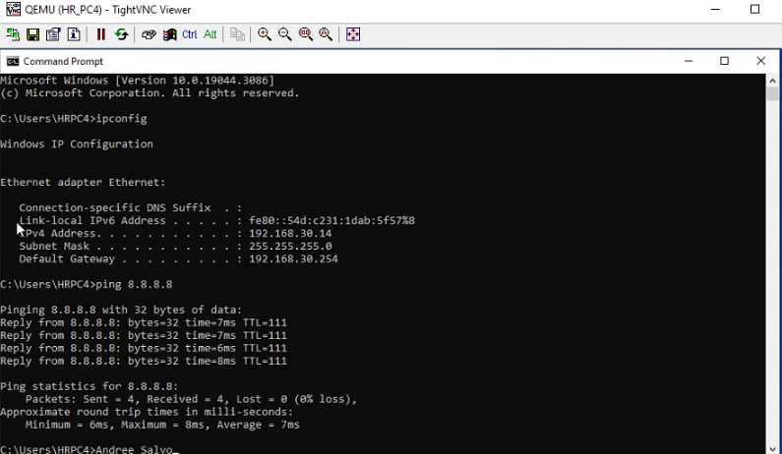
- Explain your approach to troubleshooting the issue and justify your resolution.
To fix the HR PCs, I first checked which one had internet access, and PC1 did. From there, I ran ipconfig and pinged 8.8.8.8 on the others, which failed due to some wrong default gateways. PC4 had the correct gateway but was on the wrong LAN, so I fixed all the gateway settings and made sure all PCs were on VLAN 30. After that, I pinged 8.8.8.8 again, and all the PCs connected to the internet.

